Lab 2

Commands are run using “python lab2.py R/O.csv -command” for final version.

Pictures are from different steps in development; labconnto.py assign.py and test.py

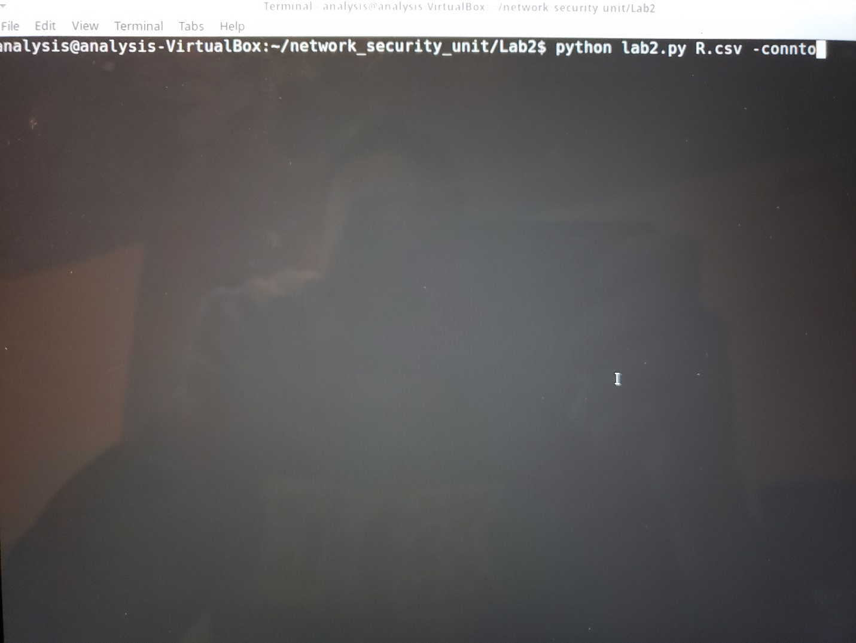

Pictures of code (I couldn’t export it out of the vm) at the end of this writeup.

1.

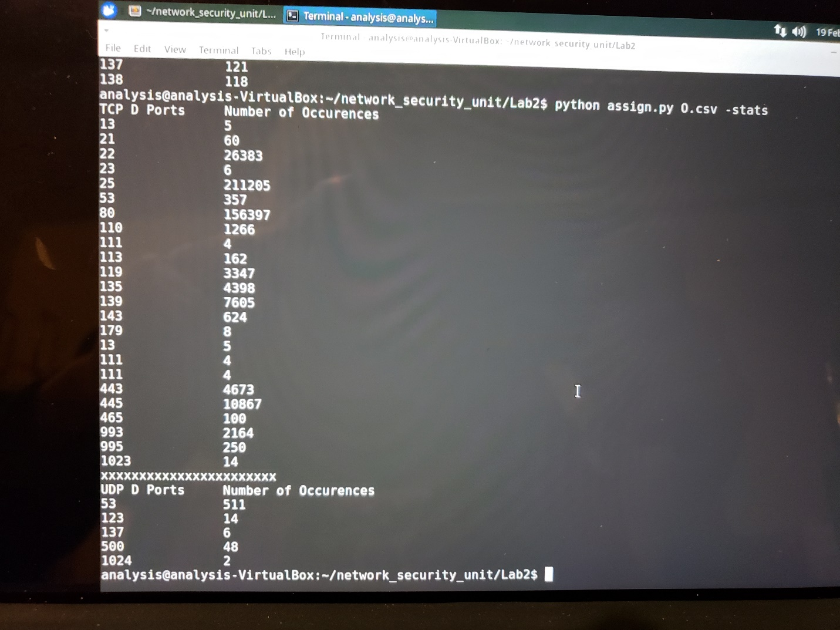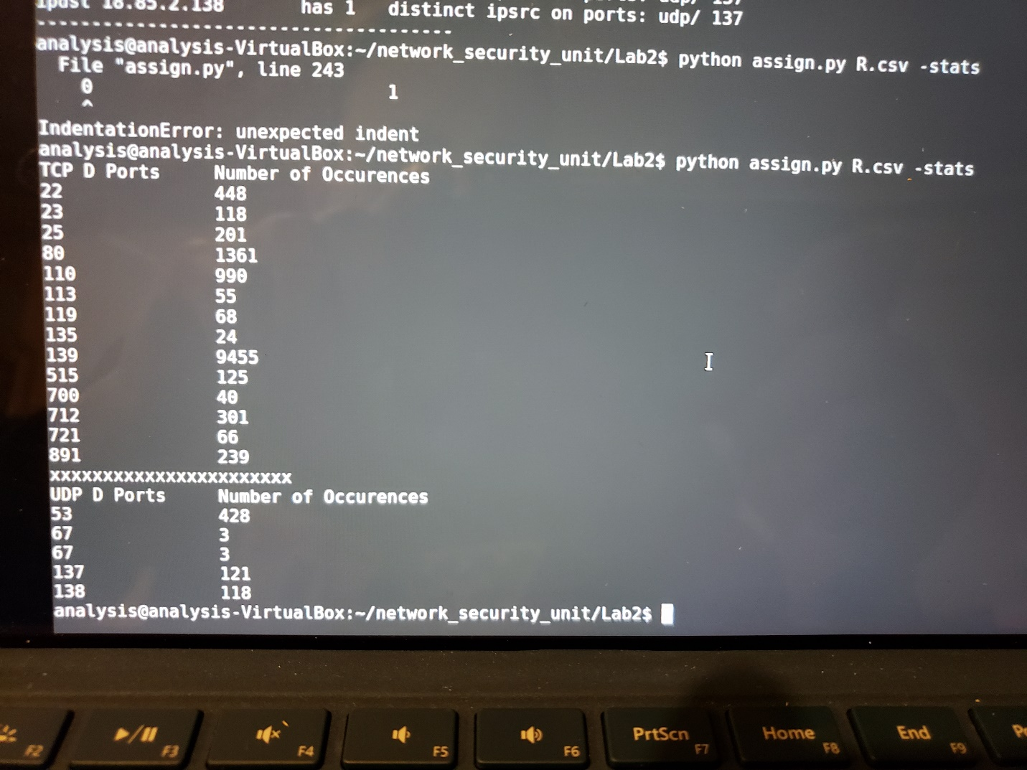

1. Judging by the large amount of IP addresses I would guess this is some kind of data center or work center.
2. Yes it does inform my answer, there is a huge amount of occurrences of hundreds of source IPs so I would guess this is a data center or major server operation.

(O data, output was so large I couldn’t scroll up enough)

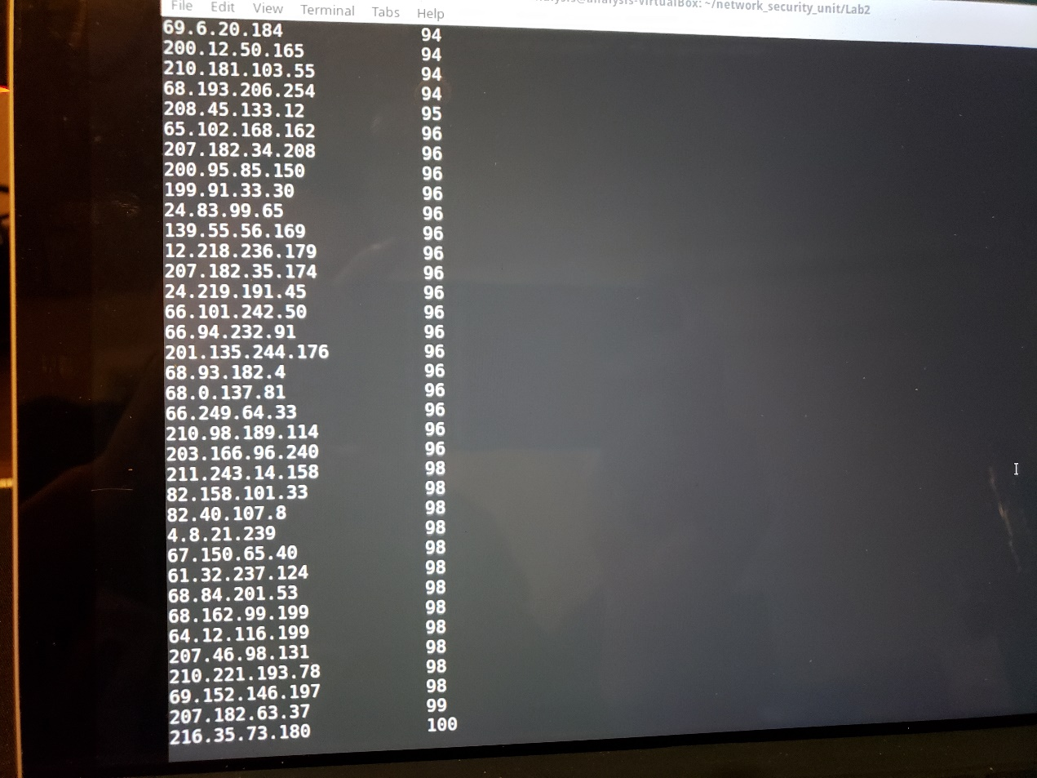

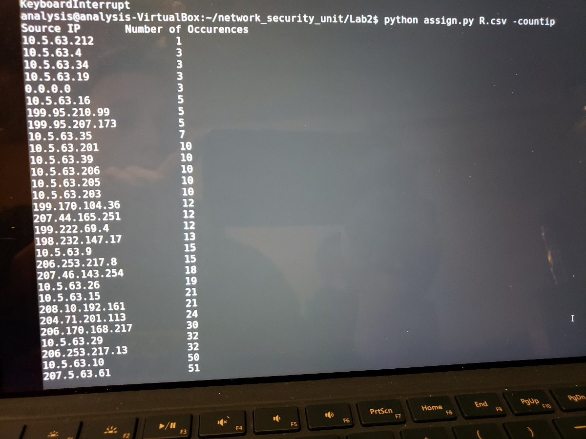

1. it looks like the 10.5.63 prefix dominates with several tens of thousands of occurrences.
2. Perhaps the 234.142.142 prefix, it has a lot of occurrences as well.
3. Yes, it confirms my suspicions.

9. results below.

10. Yes if you analyze the data see below. The ipdst’s with a large amount of distinct ipsources are likely to be the servers, the items with only a few distinct sources are likely to be user computers or printers.

11. I suppose it is a major workplace then, with a multitude of different devices (printers, mail servers, dns servers, computers) involved.

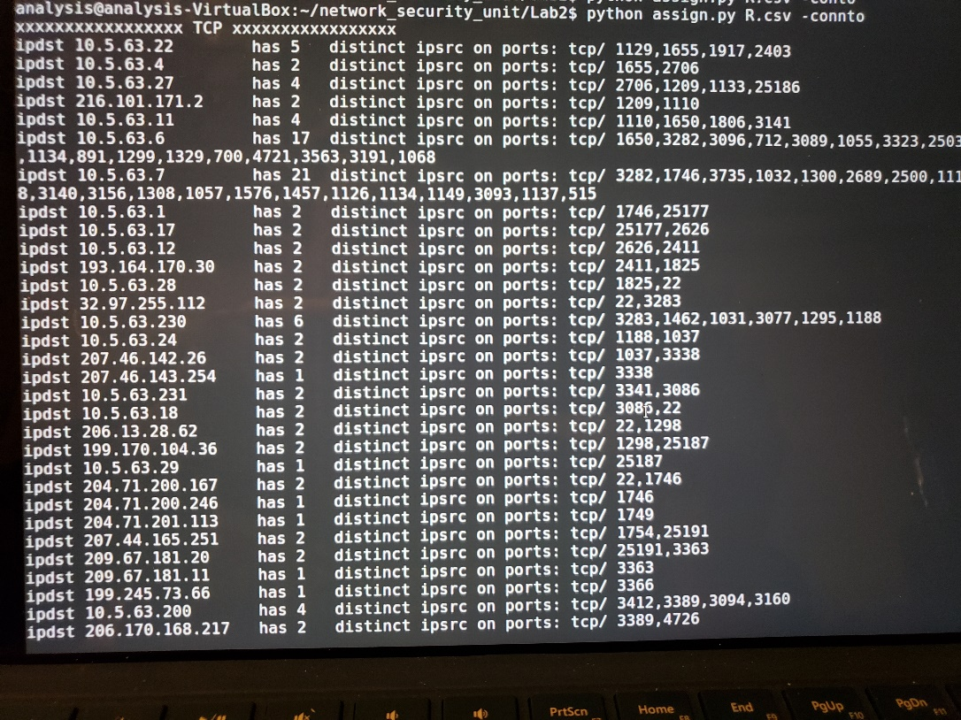-connto for R

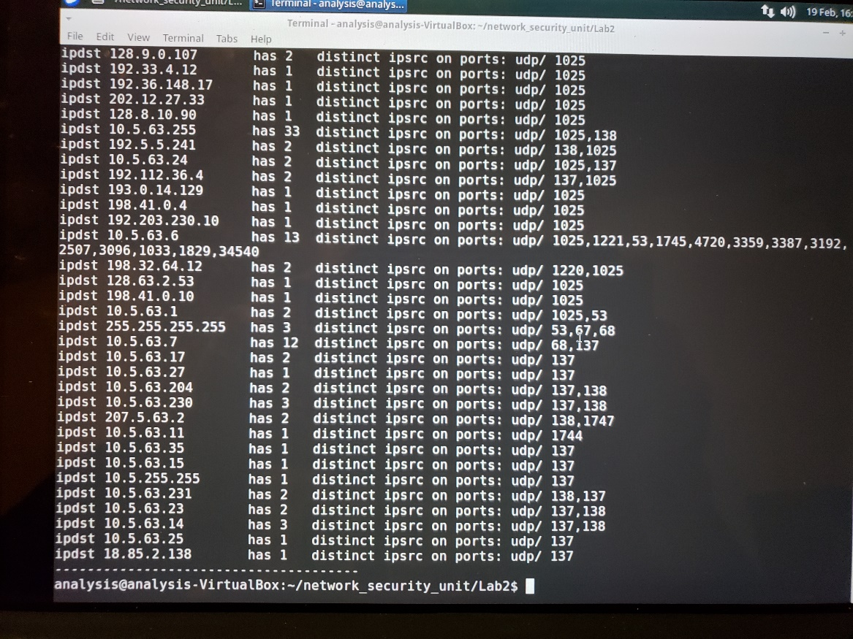-connto for O

CODE:

